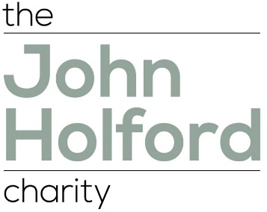

John Holford Trust Application Form

Under General Data Protection Regulations (GDPR) we will need fully informed and freely given consent from applicants (you or your client or service user) that we can hold their data for the purpose of assessing and processing applications for financial support. We will not be able to assess or process any application without the applicants written consent. A consent form can be found on the website.

John Holford Trust need them to complete and sign the form. The consent form will then need to either be posted to the Clerk to the Trust or scanned and attached to an e mail to the Clerk before an application can be considered.

If you have any questions about the consent process or GDPR generally, please contact Kerris Owen Clerk to the John Holford Trust jholfordcharity@gmail.com
Personal Details
Name of applicant
Address
Phone number
If you’re applying on someone else’s behalf (e.g. parent or carer) we need your details below
Name
Address
Organisation/Employer (if applicable)
Contact phone number
Your relationship to the applicant
Dependents (If Applicable)
Number of household dependents (children or others)
Ages of dependent children
Dependant adults
Living within the household
(Please explain why they are dependent)
INCOME AND EXPENDITURE
- Please include copies (scanned or photo) of the last three bank statements – either post these or attach to an e mail to the Clerk to the Trust.
- The trustees may ask for further evidence of income or expenditure and may explore with you your financial situation.

Reason for Application
What are you asking for?
Why are you asking?
Supporting statement from school/carer/other
Declaration
I declare that to the best of my knowledge and belief that answers contained in this application are accurate and correct.
Signed
Dated
Please note if you are applying online then simply type your name.
Counter signed
(school/carer/other)
Relationship to applicant
Dated

